WEEK 1 INTERNSHIP REPORT
Data Cleaning and Preparation Strategies

Internship Role | Junior Data Analyst – Advanced Excel
Task | Week 1 – Data Cleaning and Preparation Strategies
Dataset | Shopping Trends Dataset
Records | 3,900
Fields | 19 columns
Prepared By | Mohammad Khubaib Abdullah

1. Introduction
Data cleaning is a critical stage of the data analysis lifecycle. Before a dataset is used for reports, dashboards, business analysis, or decision-making, an analyst must understand its structure and verify that the information is reliable and consistent. Poorly prepared data can produce incorrect totals, misleading groups, and unreliable conclusions. The purpose of this Week 1 activity was therefore to practice a structured data-cleaning and preparation workflow using Microsoft Excel.
The Shopping Trends dataset used for this activity contains 3,900 records and 19 columns covering customer, product, purchase, payment, subscription, and purchasing-frequency information. The work focused on initial assessment, validation of numeric fields, text preparation, Data Validation, Text to Columns, TRIM and PROPER functions, Conditional Formatting, Advanced Filter criteria, and Pivot Table analysis. Screenshots were captured as evidence of the practical work.

2. Objectives
- Review the dataset before making unnecessary changes.
- Identify duplicate records, missing values, formatting issues, and invalid numeric values.
- Demonstrate practical Excel techniques for cleaning and preparing data.
- Use validation controls to improve future data-entry consistency.
- Use Pivot Tables to summarize prepared data for analysis.
- Document the methodology, challenges, solutions, and learning outcomes in a professional report.

3. Dataset Description
The Shopping Trends dataset contains 3,900 records and 19 fields. The fields include Customer ID, Age, Gender, Item Purchased, Category, Purchase Amount (USD), Location, Size, Color, Season, Review Rating, Subscription Status, Payment Method, Shipping Type, Discount Applied, Promo Code Used, Previous Purchases, Preferred Payment Method, and Frequency of Purchases. This combination of categorical and numeric information makes the dataset suitable for practicing data preparation.
The dataset was kept as the working source for the activity, while demonstrations that could change data structure, such as Text to Columns, were performed in separate working areas. This approach helps protect the source data and makes the process easier to trace.

4. Initial Data Assessment
The first stage was an initial quality assessment. Duplicate records were checked and no duplicate records were identified. Missing values were also checked and no missing values were identified. Because these issues were not present, no records were deleted and no artificial values were inserted. This is an important professional practice: cleaning should be based on evidence rather than changing data simply to make it appear cleaner.
The Review Rating field was checked against an expected range of 0 to 5. Conditional Formatting rules were used to identify values below 0 and above 5. Purchase Amount was also considered for invalid negative values. Categorical fields such as Category, Subscription Status, and Payment Method were reviewed for consistency.

5. Data Quality Assessment Summary
Check | Observation | Action
Dataset size | 3,900 records; 19 fields | Used as working dataset
Duplicate records | No duplicates identified | No deletion required
Missing values | No missing values identified | No imputation required
Review Rating | Checked against 0–5 range | Conditional Formatting validation
Purchase Amount | Checked for inappropriate negative values | Numeric quality check
Text fields | Reviewed for consistency | TRIM/PROPER and validation demonstrated

6. Data Cleaning Methodology
The cleaning methodology followed a controlled sequence. First, the source data was reviewed without making unnecessary changes. Second, duplicate and missing-value checks were completed. Third, numeric validation rules were applied to important fields. Fourth, Excel functions and tools were demonstrated for text standardization, controlled data entry, filtering, and visual quality checks. Finally, Pivot Tables were used to summarize the data and demonstrate how prepared fields can support analysis.

6.1 Duplicate Check
Duplicate checking is important because repeated rows can inflate totals and customer counts. The dataset was checked for duplicate records and none were identified. Therefore, no records were removed. This preserves the integrity of the original information.

6.2 Missing Value Check
The dataset was reviewed for blank or missing values. No missing values were identified. As a result, there was no need to remove records or fill blanks with assumed information.

6.3 Numeric Validation
Review Rating was checked against a 0–5 range. Values below 0 and above 5 were targeted with Conditional Formatting so that an analyst could immediately identify any out-of-range values. Similar checks can be applied to Age, Purchase Amount, and Previous Purchases.

7. TRIM and PROPER Functions
Text consistency is important because extra spaces and inconsistent capitalization can make apparently identical values behave differently during filtering, matching, or grouping. The TRIM function was demonstrated with the formula =TRIM(A2). It removes unnecessary spaces from a text value. The PROPER function was then demonstrated with =PROPER(B2), converting text such as 'rahul sharma' into 'Rahul Sharma'.
These functions are useful for customer names, product names, addresses, and other text fields. A typical preparation sequence is to remove unwanted spaces first and then standardize capitalization. This improves readability and consistency without inventing or changing the underlying meaning of the text.
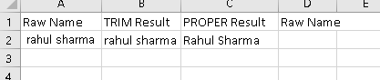
Figure 1: TRIM and PROPER demonstration for text standardization.

8. Text to Columns
Text to Columns is useful when one cell contains multiple logical values that should be analyzed separately. In the demonstration, names such as Rahul Sharma, Aamir Khan, and Sameer Patel were entered in one column. The Data → Text to Columns command was used with Space as the delimiter, producing separate first-name and last-name columns.
- Select the source text range.
- Open Data → Text to Columns.
- Choose Delimited.
- Select Space as the delimiter.
- Review the preview and finish the operation.
- Check the resulting columns for correct placement.
This technique is useful for imported customer data, addresses, product descriptions, or other combined fields. The source should be preserved before splitting columns because Text to Columns changes the structure of the selected range.
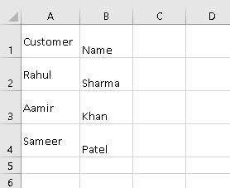
Figure 2: Text to Columns demonstration separating first and last names.

9. Data Validation
Data Validation was used to demonstrate preventive data-quality control. A predefined list of acceptable payment methods was created: Credit Card, Debit Card, Cash, PayPal, Venmo, and Bank Transfer. A dropdown was then applied to a cell. The user can select an approved value rather than typing an inconsistent variation.
This technique is particularly useful in operational spreadsheets where multiple people may enter information. It reduces spelling differences and improves the consistency of categorical fields. Better consistency also improves later filtering, Pivot Table grouping, and reporting.
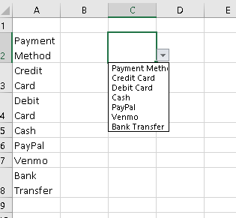
Figure 3: Payment Method Data Validation dropdown.

10. Conditional Formatting
Conditional Formatting provides a fast visual method for identifying patterns and potential problems. The Purchase Amount field was prepared for visual comparison using a color scale. Numeric values can then be scanned quickly for relatively low and high amounts. Conditional Formatting was also used conceptually for validation rules such as Review Rating below 0 or above 5.
The technique is useful because a large dataset can contain thousands of values that are difficult to inspect manually. Visual rules make exceptions easier to investigate and can be adapted for duplicates, blanks, threshold breaches, or business-specific conditions.

11. Advanced Filtering
Advanced filtering was prepared using two criteria: Category = Clothing and Subscription Status = Yes. The criteria were placed in a separate range so they could be applied to the source dataset without altering the original values. This demonstrates how an analyst can define multiple conditions and isolate a specific subset for focused analysis.
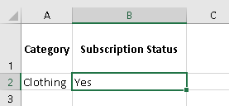
Figure 4: Criteria prepared for Advanced Filtering.
In a real reporting workflow, the filtered results could be copied to another location for additional analysis. Advanced Filter is useful when several conditions must be applied together and when the analyst wants to keep the criteria visible and reusable.

12. Pivot Table Analysis
Pivot Tables were already present in the workbook and were used as supporting analysis. The screenshot shows three summaries. The first groups Purchase Amount by Category and also displays average Purchase Amount. The second summarizes Purchase Amount by Location. The third counts Customer IDs by Subscription Status.
The category summary displays totals for Accessories, Clothing, Footwear, and Outerwear. In the displayed Pivot Table, Clothing has a total Purchase Amount of 104,264 and an average of approximately 60.03. The subscription summary shows 2,847 records under No and 1,053 under Yes, giving a grand total of 3,900 Customer IDs. These summaries demonstrate the importance of consistent categorical and numeric fields because Pivot Tables rely on those fields to create meaningful groups.
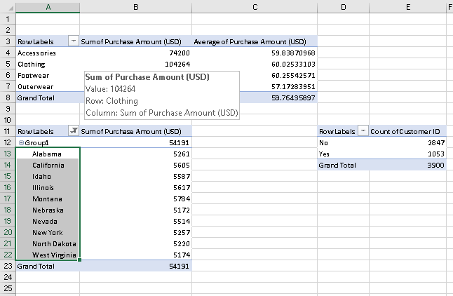
Figure 5: Existing Pivot Table summaries for category, location, and subscription status.

13. Challenges Faced and Solutions
A key challenge in data preparation is deciding whether a difference is actually an error. An analyst should not modify a value simply because it looks different. The approach used in this activity was to define checks first and then assess the data against them. For example, Review Rating was checked against a defined 0–5 range instead of being changed without evidence.
Another challenge is text consistency. TRIM and PROPER were demonstrated to address spaces and capitalization, while Text to Columns was used to separate combined values. Data Validation was used as a preventive measure for future data entry, and Conditional Formatting was used as a visual inspection method.
Preserving the raw source is also an important operational practice. Keeping an original copy and using a working copy or separate preparation area makes the workflow traceable and reduces the risk of accidental data loss.

14. Before and After Preparation
Area | Assessment | Preparation Outcome
Duplicates | Checked | No duplicates identified
Missing values | Checked | No missing values identified
Text quality | Reviewed | TRIM and PROPER demonstrated
Combined names | Single text field in demonstration | Text to Columns demonstrated
Future payment entry | Could vary if manually typed | Dropdown validation demonstrated
Numeric quality | Requires range checks | Conditional Formatting demonstrated
Analysis | Fields available for summary | Pivot Tables available
The result is not simply a changed spreadsheet; it is a documented preparation process. The process identifies what was checked, what issues were actually present, and which Excel tools can be used to prevent or correct quality problems.

15. Reflection and Learning Outcomes
This activity showed that data cleaning is more than deleting duplicates or filling blank cells. A good analyst begins by understanding the data and defining rules for quality. The next step is to select techniques that directly address the identified problem. Preventive controls such as Data Validation are valuable because they reduce the chance of inconsistent values entering the dataset in the future.
The activity also demonstrated the relationship between data preparation and analysis. Pivot Tables can quickly summarize thousands of records, but their usefulness depends on consistent fields. Text functions, validation rules, and visual checks therefore contribute directly to the reliability of later reports and dashboards.
From a practical learning perspective, the task improved familiarity with Excel's Data and Home tabs, formula-based text cleaning, controlled dropdowns, filtering criteria, and summary analysis. These are foundational skills for a junior data analyst and can be reused across sales, customer, finance, operations, and HR datasets.

16. Conclusion
The Week 1 task provided an end-to-end practice workflow for data cleaning and preparation using Excel. The Shopping Trends dataset was assessed for duplicates, missing values, numeric validity, and consistency. No duplicate records or missing values were identified during the initial checks. The activity then demonstrated TRIM, PROPER, Text to Columns, Data Validation, Conditional Formatting, Advanced Filter criteria, and Pivot Tables.
The final approach emphasizes accuracy, traceability, and repeatability. Rather than making unsupported changes, the data was checked against defined rules and the preparation techniques were documented with visual evidence. This creates a stronger foundation for future analysis, dashboards, and business reporting and demonstrates both technical Excel skills and analytical reasoning.

17. Excel Techniques Reference
Technique | Purpose
TRIM | Removes unnecessary spaces from text.
PROPER | Standardizes capitalization of text.
Text to Columns | Splits combined text into separate fields using a delimiter.
Data Validation | Restricts future entries to approved values.
Conditional Formatting | Highlights values or patterns using rules.
Advanced Filter | Filters records using defined multiple criteria.
Pivot Table | Groups and summarizes large datasets for analysis.

